The following are the procedures followed Starting 08/03/06.
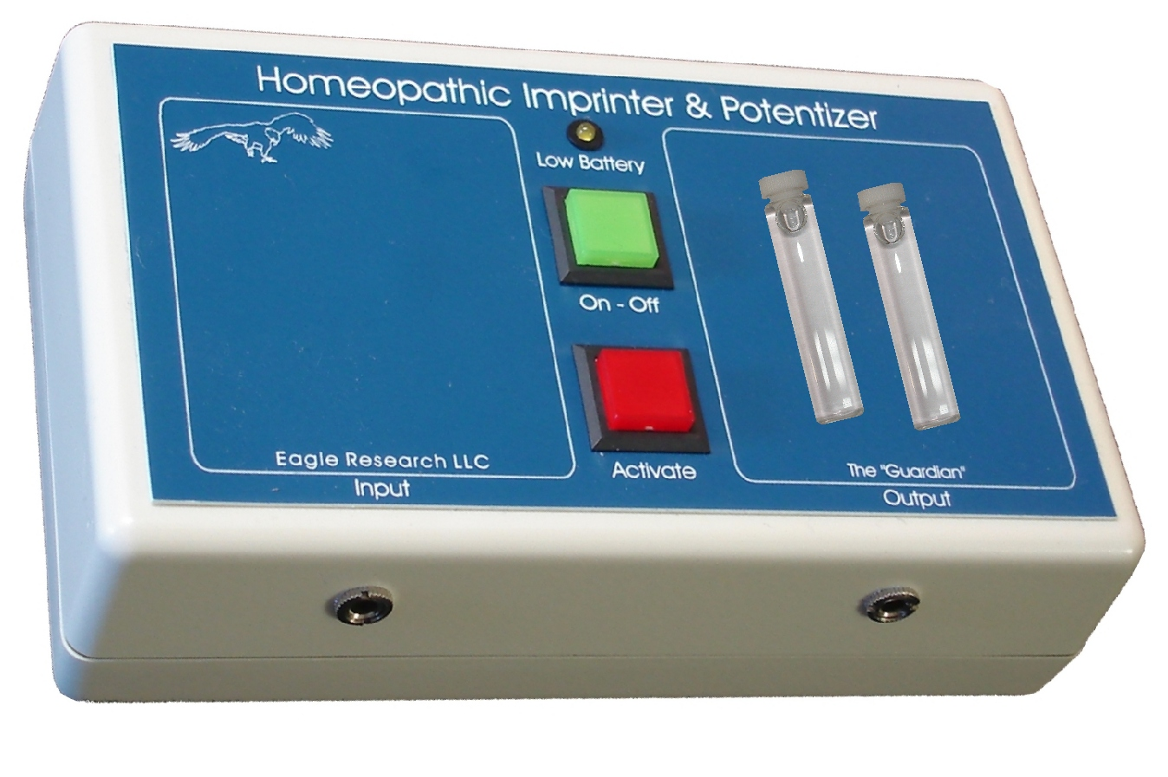

- With two vials on the output side, plug the collecting plate into the guardians left side jack.

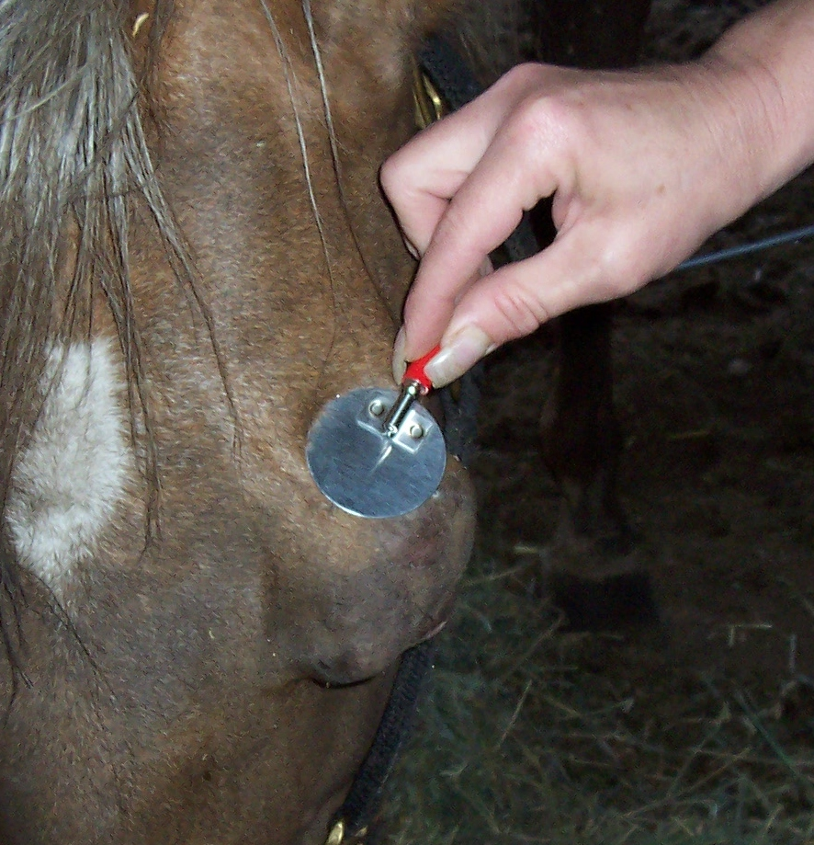

- Place input plate on the tumor and press the red button.

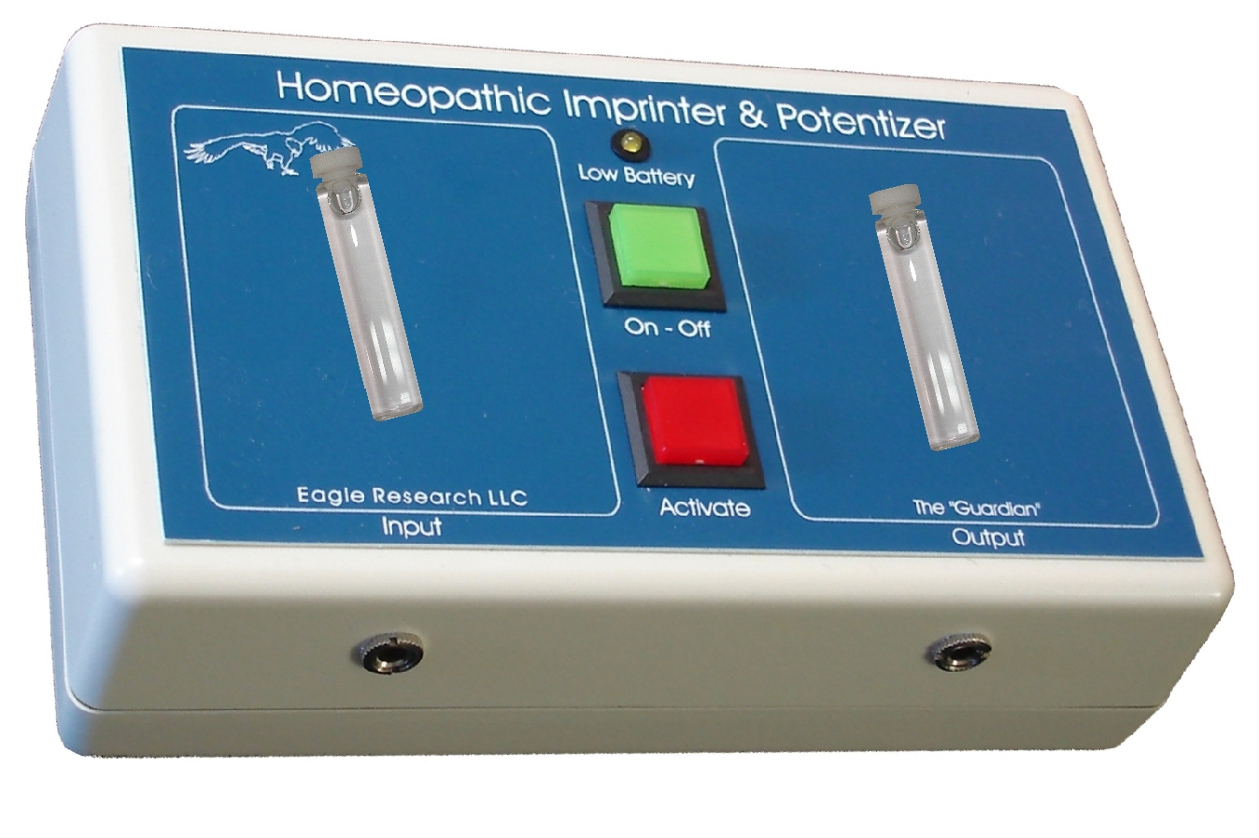
- Remove the plate from the input jack.
- Place one of the two vials on the left (input) side and press the red button.
- Swap the vials and press the red button.
- Swap the vials and press the red button.
- Swap the vials and press the red button (added 08/11/06).
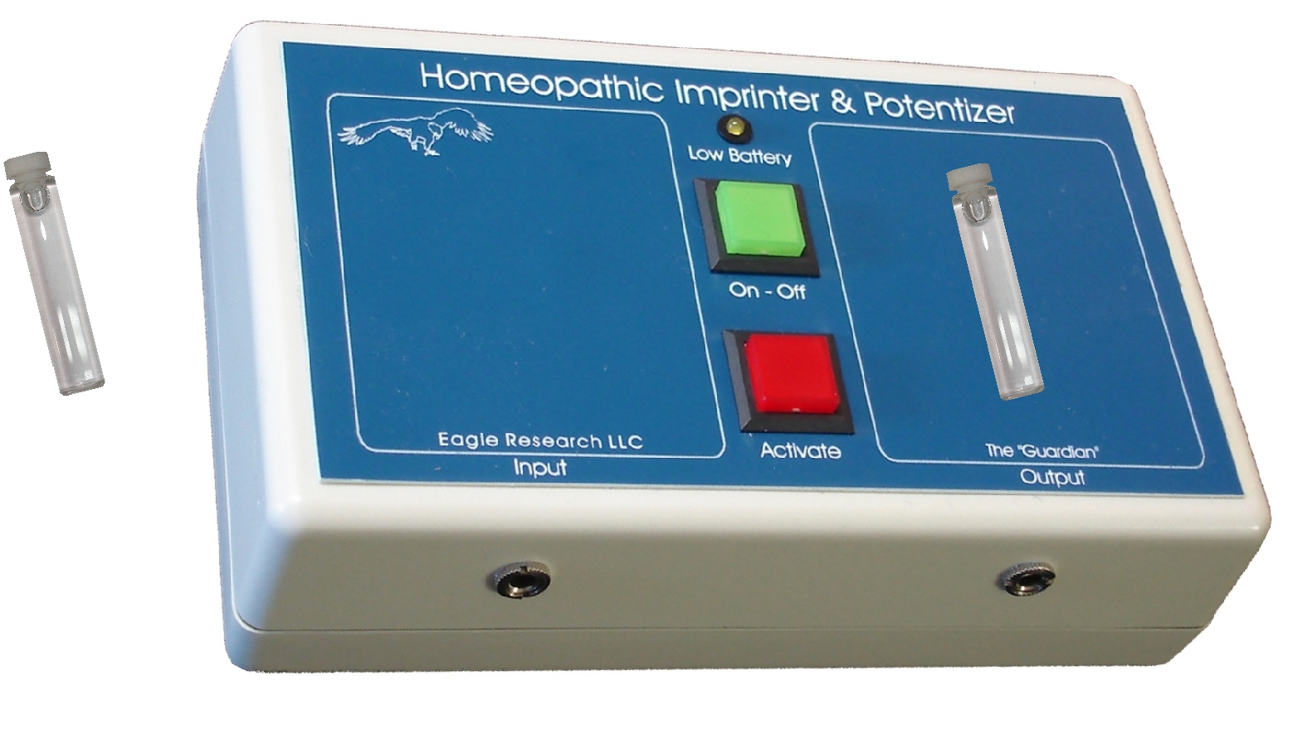

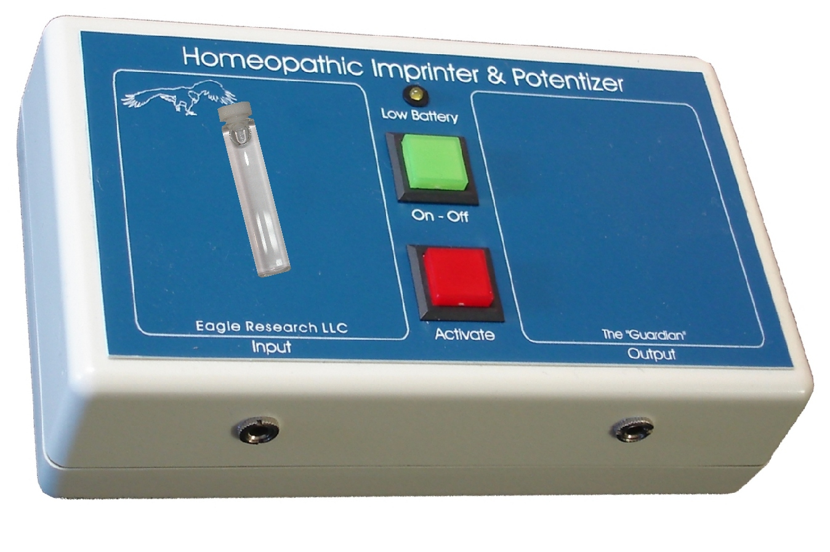
- Remove the vial on the left (input) and place the vial on the right (output) on the left.

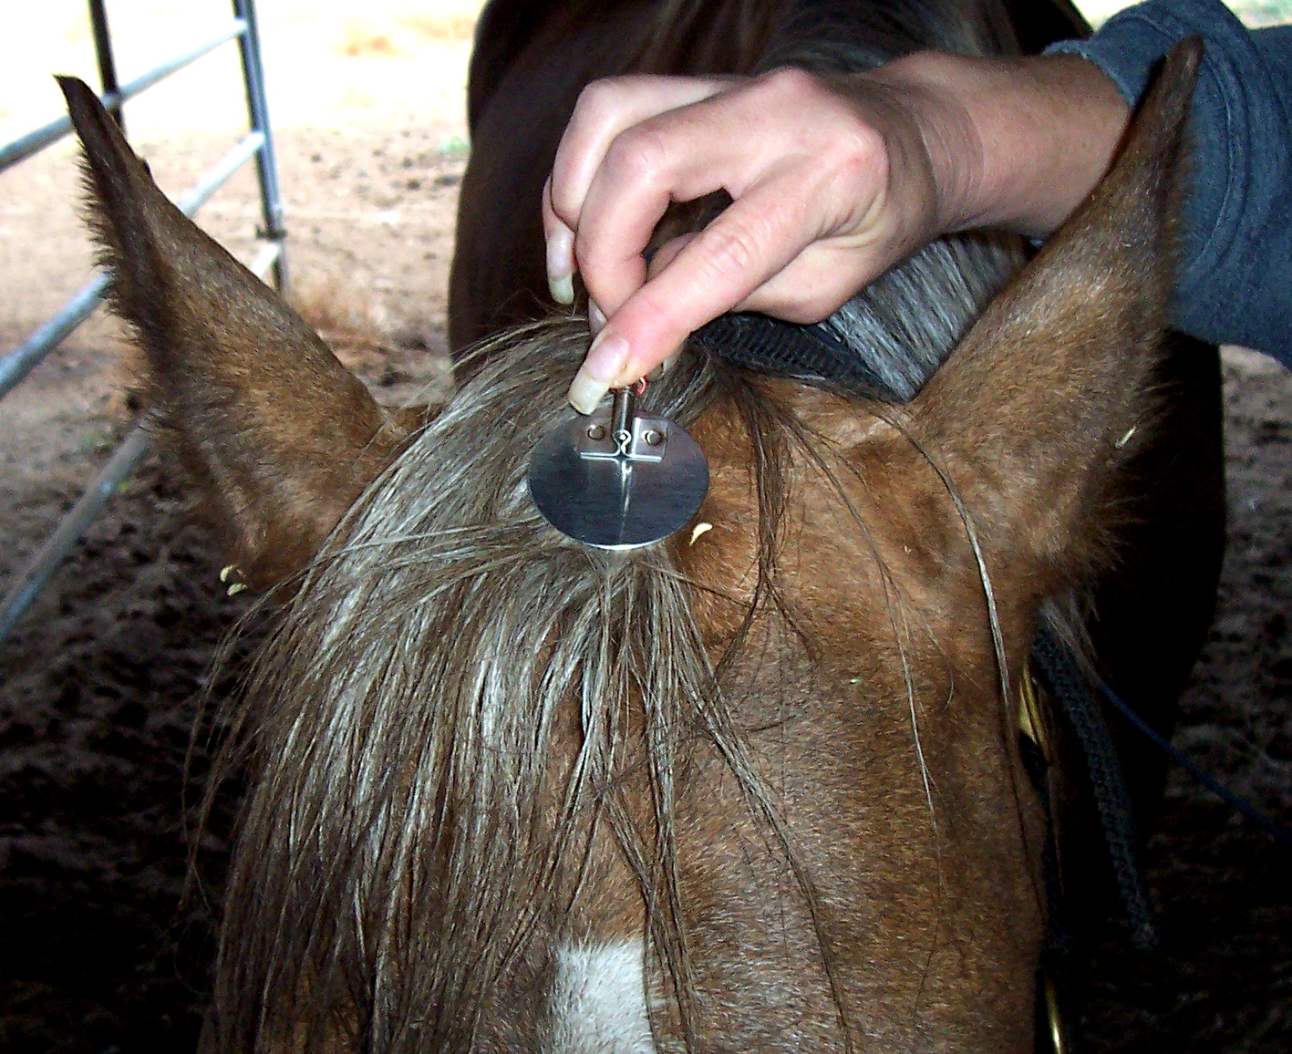

- Plug the plate in the right jack (output), place the plate between the ears and press the red button. Wait a few seconds and press the red button again. (Changed 08/13) Repeat 4 times.

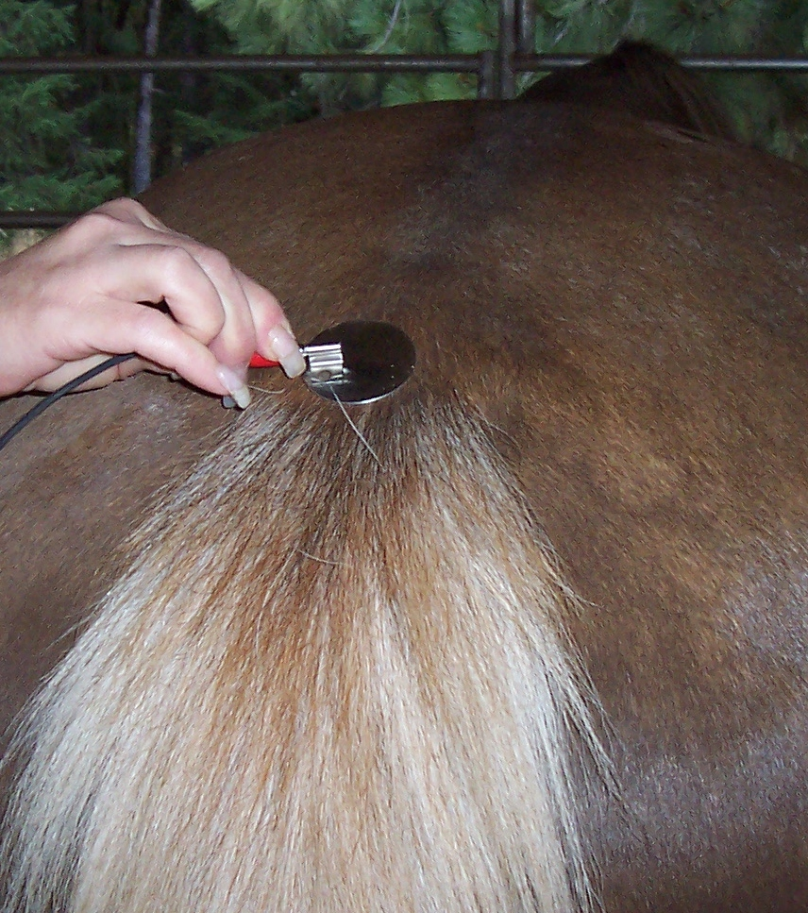

- (Added 08/07/06 – mid-day) Place the plate where the tail meets the body and press the red button. Wait a few seconds and press the red button again. (Changed 08/13) Repeat 4 times.

Remove the vile from the input side and place it on Cindy.

Repeat this process three times a day. (Changed 08/13) Repeat 2 times daily.

